CMSC 678 Project 1
Paul Hudgins
Department of Computer Science
Virginia Commonwealth University
Richmond, VA, USA

Experiments without Outlier
The perceptron trained by Method 1 as specified in Part 1 completed training in 12 epochs with w = [-0.5954 -0.7314 3.1000]. All training points were correctly classified. Results are shown below.
Experiments with initial weight vector of [1 1 1] and various values of Eta showed that training completed with the fewest epochs with Eta = 0.01. Results are shown to the right. Eta had no effect on number of epochs with initial weights of [0 0 0].
In batch mode, the perceptron still correctly classified all training points, but the boundary seemed to have worse margins than with iterative training.

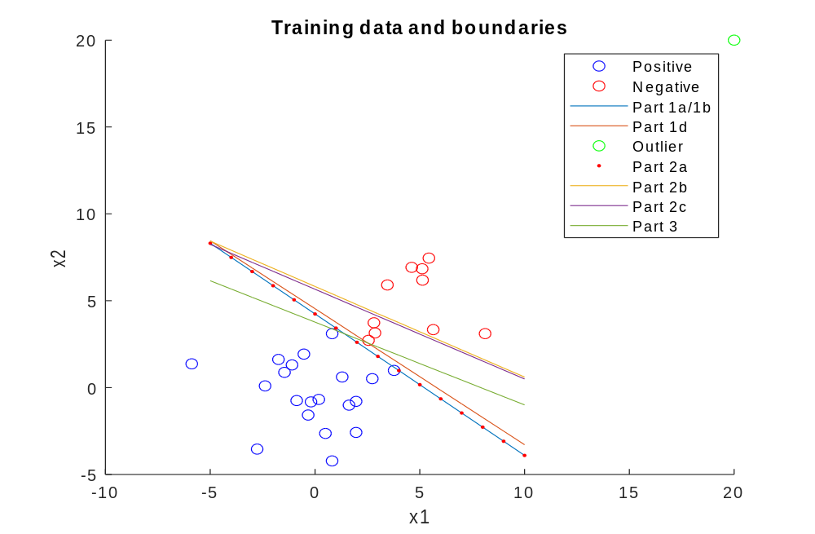
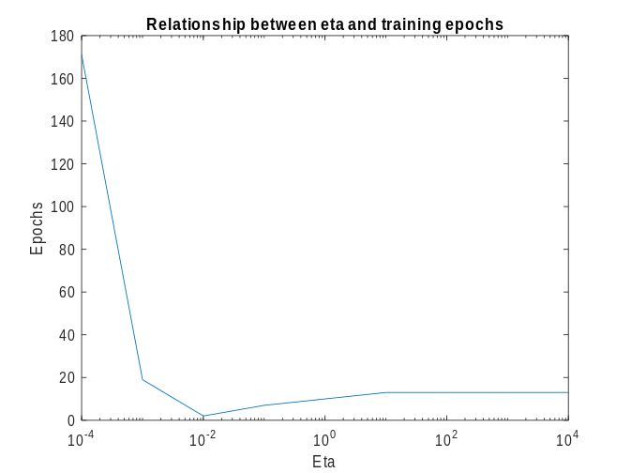

Experiments with Outlier
After adding an outlier, an iteratively trained perceptron produced the same boundary as in part 1a. A perceptron trained in batch mode without regularization failed to correctly classify three points.
Training in batch mode with penalty parameter of 1 produced similar results to the batch mode without regularization, but moved slightly towards the correct boundary location.

Cross-Validation
10-fold cross validation was performed to determine the best penalty parameter. Results are shown below. By inspection, the best penalty parameter was determined to be 20. Training with this value of lambda produced w = [-0.0436 -0.0915 0.3447]. The resulting separation boundary is shown for Part 3 in the first figure.

